-What is kernel and It's a kernel module (**.ko) ?
- Its not an OS - its the layer that is used to talk to the hardware, that takes care of memory allocation, cpu scheduling, system calls and drivers

What is hardware visualization ? - Virtualization technique. Xen was famous for paravirtualization
This explains why Xen and KVM tools have different paths.
- A Kernel is expected to be the boss with full privilege access to hardware but ….
- When you put that kernel inside a VM, the hypervisor becomes the real boss. the Kernel inside the VM must not be allowed to execute privilege instructions on the real hardware. But the kernel inside the VM was written believing it can. Virtualization is what resolves this lie efficiently. There are 3 techniques:
- Full virtualization via software tricks (early VMware 1900s):
the hypervisor watches the VM and intercepts any privileged instructions, faking the result, but it cannot police it for long
- Paravirtualization (Xen´s pathway to fame - 2003):
Instead of fooling the guest VM kernel, it modifies the guest OS source code, so its called “Virtualization”, so the guest kernel need to ask the hardware kernel to help with privilege access, “cooperating/para”
- Hardware-assisted virtualization (Intel, AMD): Manufacturers built-in . Hypervisor mode, and Guest mode (VM) - MOST EFFICIENT & NOW ADOPTED

What are Hypervisors? It loads on physical hardware to manage and isolate multiple Virtual Machines, while sharing the real hardware (CPU, RAM, disk, network) between them.
they are 2 major types:
- Type 1 ("bare-metal") — runs directly on the hardware, with no operating system underneath. Examples: Xen, VMware ESXi, Hyper-V.
  - Xen (this isolate VMs securely) - it uses Dom0 for privilege management
  - KVM (Kernel base virtual machine) - kvm.ko- when installed it turns a standard Linux OS into a hypervisor
- Type 2 ("hosted") — runs as an application on top of a normal OS. Examples: VirtualBox, VMware Workstation.

Alibaba & AWS migrated from Xen to KVM , IBM cloud, Oracle cloud also
Only Microsoft Azure operates on a customized version of Hyper-V not KVM.

Canonical — Practical considerations for Building Sovereign Cloud
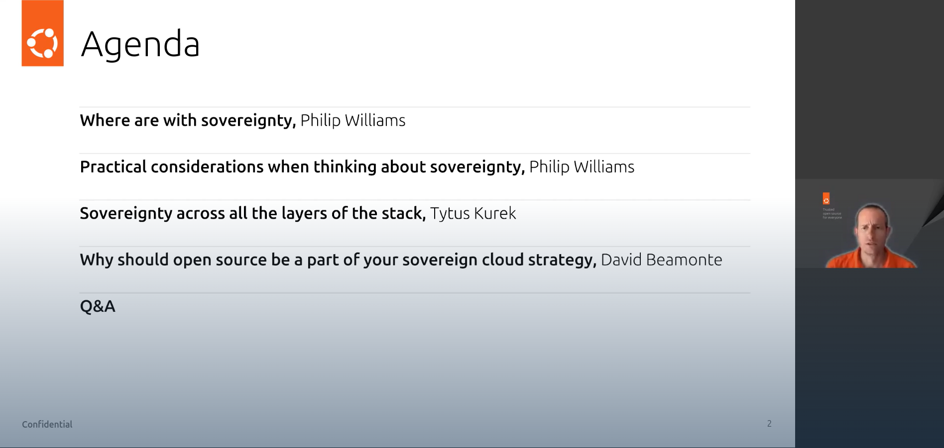
Event notes · July 2026
Agenda / speakers
- Where are we with sovereignty — Philip Williams
- Practical considerations when thinking about sovereignty — Philip Williams
- Sovereignty across all the layers of the stack — Tytus Kurek
- Why should open source be a part of your sovereign cloud strategy — David Beamonte
- Q&A

1. Why sovereignty is important
Three converging drivers:
- Geopolitics — dependency on foreign (mostly US) hyperscalers is increasingly seen as a strategic risk.
- New regulations — a wave of EU legislation directly affects cloud and digital infrastructure.
- Economics — cost control and avoiding lock-in pricing power of proprietary vendors.

2. The regulatory landscape (EU)
All of the acts below are EU-level legislation. The difference is the type of legal act:

EU Regulations — directly applicable, one rulebook EU-wide
Apply to companies as written, identically in all member states. No national translation needed.
Act | Scope
GDPR — General Data Protection Regulation | Personal data protection
DORA — Digital Operational Resilience Act | Financial entities + their critical ICT/cloud providers (applies since Jan 2025)
CRA — Cyber Resilience Act | Products with digital elements (main obligations from 2027)

EU Directive — aimed at member states, transposed nationally
Sets the end result; each member state decides how to achieve it through its own national law. Companies comply with the national implementing law, which differs per country.
Act | Scope
NIS2 — Network and Information Security Directive | Cybersecurity risk management + incident reporting for essential/important entities, incl. cloud providers, data centers, MSPs. In Germany: transposed via the NIS2-Umsetzungsgesetz (amended BSIG)
Practical consequence: GDPR/DORA/CRA compliance is largely uniform across the EU; NIS2 means tracking 27 national rulebooks.

3. Sovereignty across all the layers of the stack
(Talk by Tytus Kurek)
Sovereignty must cover the full infrastructure stack — a sovereign application on a non-sovereign layer below it is not sovereign.
flowchart TD
A[Software / applications] --> B[Observability]
B --> C[Virtualization / cloud platform]
C --> D[Networking]
D --> E[Storage]
E --> F[OS]
F --> G[System management]
G --> H[Hardware / metal]

Layer-by-layer notes:
- Hardware — sovereignty starts at the metal (see MAAS below).
- OS — Ubuntu as the open-source base layer.
- Virtualization — KVM is not controlled by any single company; many companies contribute to it. It acts as the "center of gravity" of open virtualization.
- Networking — native integration with Kubernetes; probably the future direction.
- Storage — object storage and file storage (see Ceph below).

4. Open source is the natural foundation for digital sovereignty
- ~70% of organizations already agree with this — open source means they are not forced into vendor lock-in.
- Necessary but not sufficient — open source alone doesn't make you sovereign; operations, data placement, and the full stack matter too.

5. Canonical options (product mapping)
Versatile virtualization
- Canonical MicroCloud and Canonical OpenStack — open-source cloud platforms across scales.
Ceph — because data sovereignty is not only a storage location. Ceph matters for:
- Verifiable data placement
- Cloud-compatible storage under your own control
- Resilience by design
- No dependency on proprietary storage platforms
MAAS (Metal as a Service)
- "Operational sovereignty starts at the metal" — bare-metal provisioning and control of your own hardware.

6. Reference adopters of Canonical stacks
- UNICC — United Nations International Computing Centre
- UIDAI — Unique Identification Authority of India; handles digital identity for 1.4+ billion people

Key takeaways
- Sovereignty is driven by geopolitics, regulation, and economics — not just compliance.
- Know your legal instruments: Regulations (GDPR, DORA, CRA) apply directly; the NIS2 Directive reaches you through national law.
- Sovereignty is a full-stack property — hardware to application, including operations and observability.
- Open source is the natural foundation (KVM, OpenStack, Ceph, Ubuntu) — necessary, but not sufficient on its own.

Building a sovereignty cloud
- Determining Customer Zero: First is to decide that you need a cloud for private use. With the possibility of expanding to other companies tomorrow
- Rent certified colocation space (e.g Frankfurt area, near DE-CIX): facility's power, cooling, physical security and later after scaling then you get your own facility
- Commit to: OpenStack + Ceph + KVM, deployed via Kolla-Ansible or similar. (OpenStack is an open-source cloud operating system that controls large pools of compute, storage, and networking resources across a data center)
- Hire the six profiles Engineers
- platform engineers, python, distributed systems, COA – because Open stack is written in Python )
- Ceph storage engineers, (The scarcity of Ceph and OpenStack operators in Europe is itself a sovereignty constraint)
- SDN/network engineers, : two layers-
1. Virtual network (Neutron with OVN/Open vSwitch, VXLAN overlays)
2. Physical underlay (BGP, EVPN, peering at DE-CIX)
- deployment & automation engineers,
- SREs,
- security & compliance
- Launch minimal IaaS for customer zero; expand via thin managed services; certify in parallel.
Technical construct, on building the IaaS and launching.
Step 1 : Physical Design : Node roles and the hardware BOM
Purchasing the servers/nodes. e.g 1U/2U pizza-box.
Each of these pizza box are racked up together as seen below:
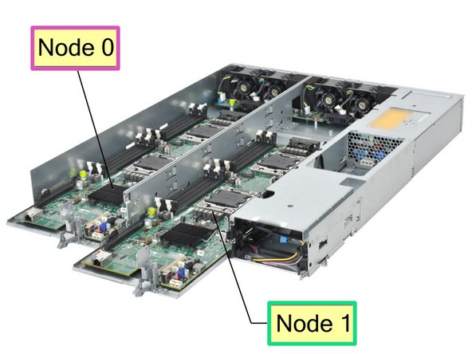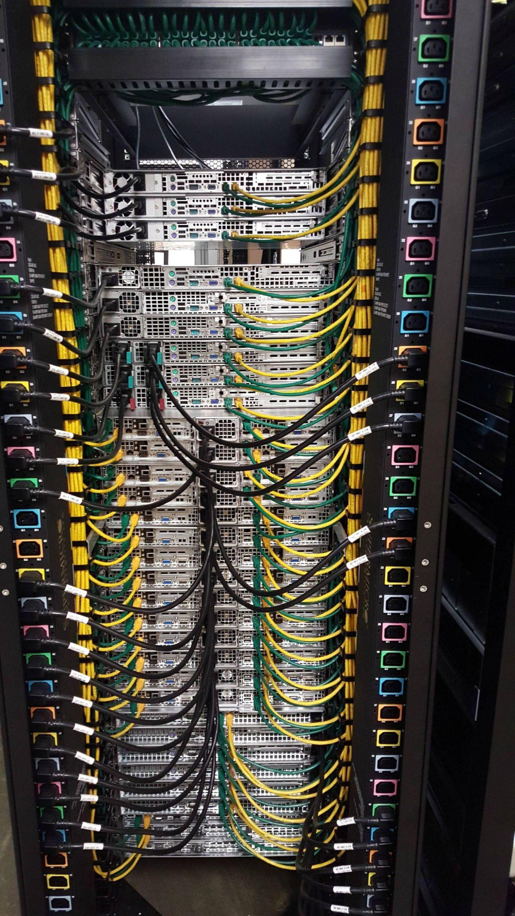

Each of these combined Pizza boxes can be used as a compute node, storage node, or control node. by installing the right parts & software.
- Design the cluster topology on paper (An OpenStack cloud can consist of multiple servers as follows:
- Multiple control-plane nodes. These run the OpenStack APIs (Keystone, Nova, Neutron, Glance, Cinder)
- Ceph storage nodes.
- Compute nodes (hypervisors). KVM hosts running Nova-compute
- Network/edge nodes: to moving data between ports at very high speed
- Others: Top-of-rack switches,
- Out-of-band management switch connected to every server's BMC/IPMI port (for the SRE engineers to remotely access),
Total: roughly 12–15 servers, 5 network devices, 2 racks
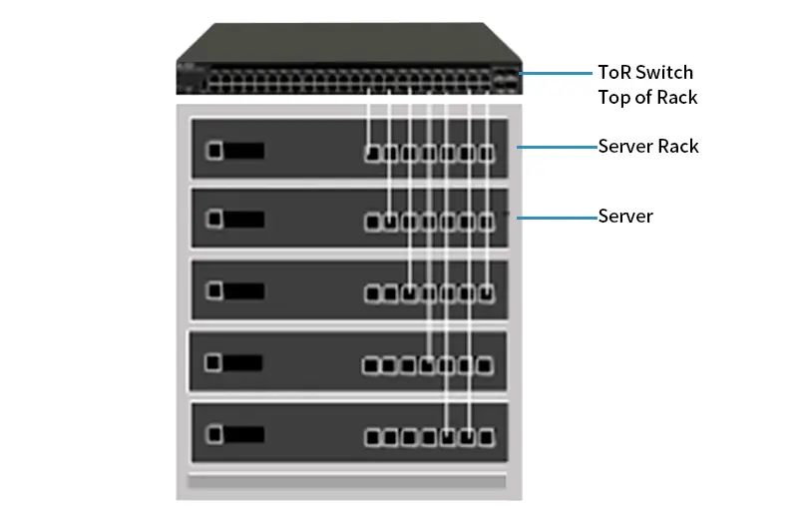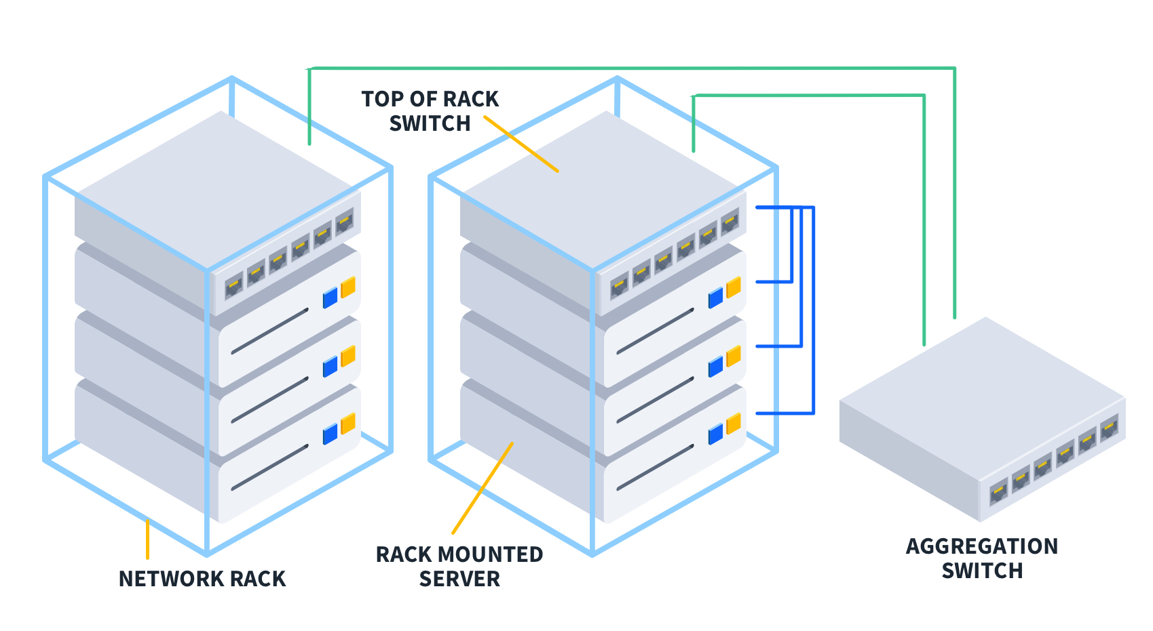
So: routers connect us to the outside world,
(Top of Rack) ToR switches connect our own servers to each other,
management switch is a separate emergency-access lane 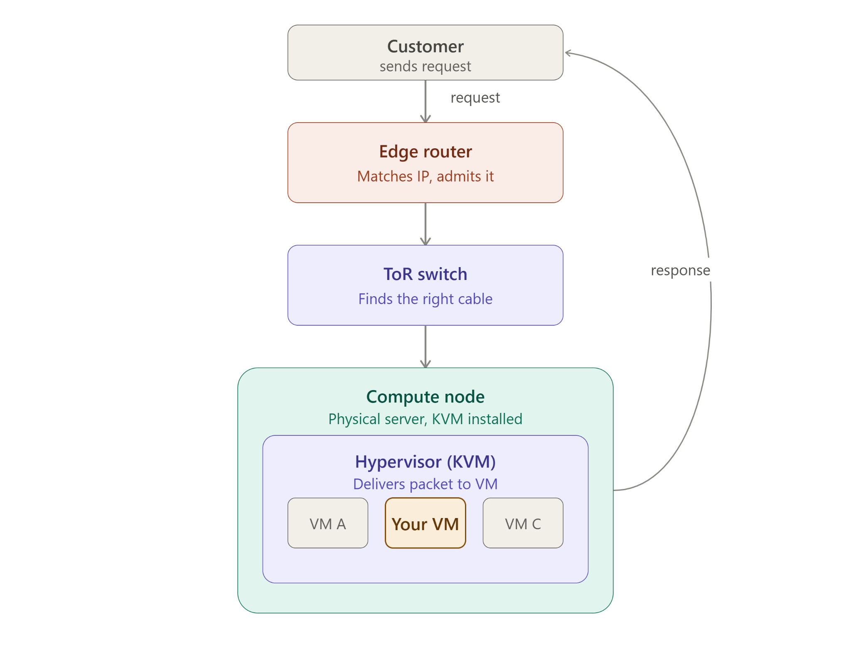
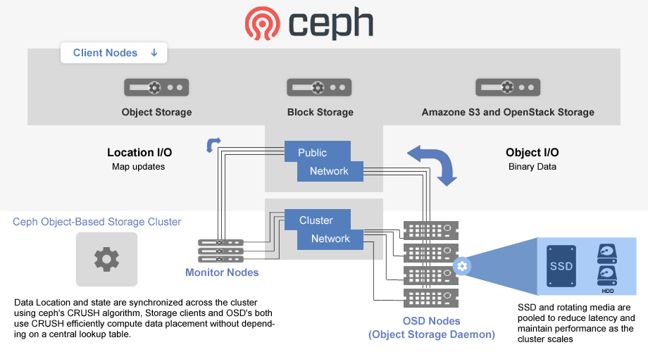
BOM
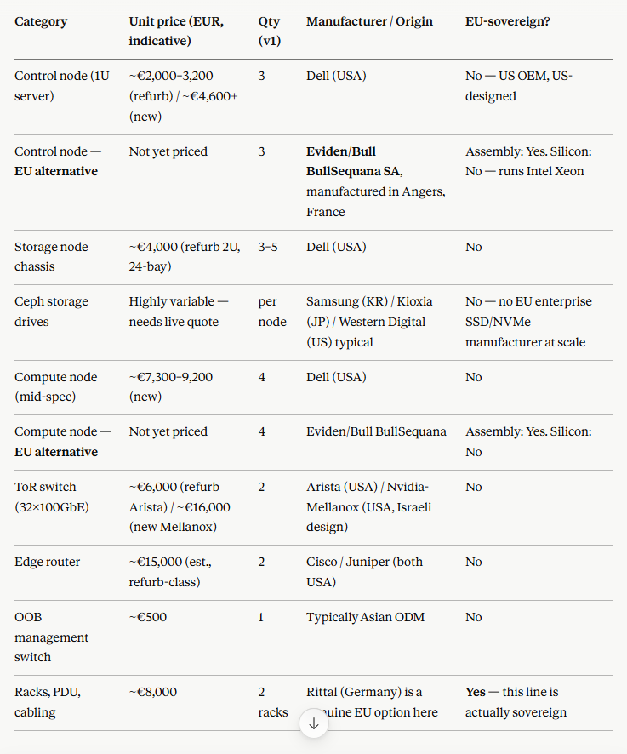

Technical Step 2 — The network underlay: separating traffic into isolated lanes.
Servers-to-servers communications, uses physical cables, how to connect them to carry several completely separate conversations at once, and mixing them is both a security risk and a performance risk. The trick is VLAN tagging.
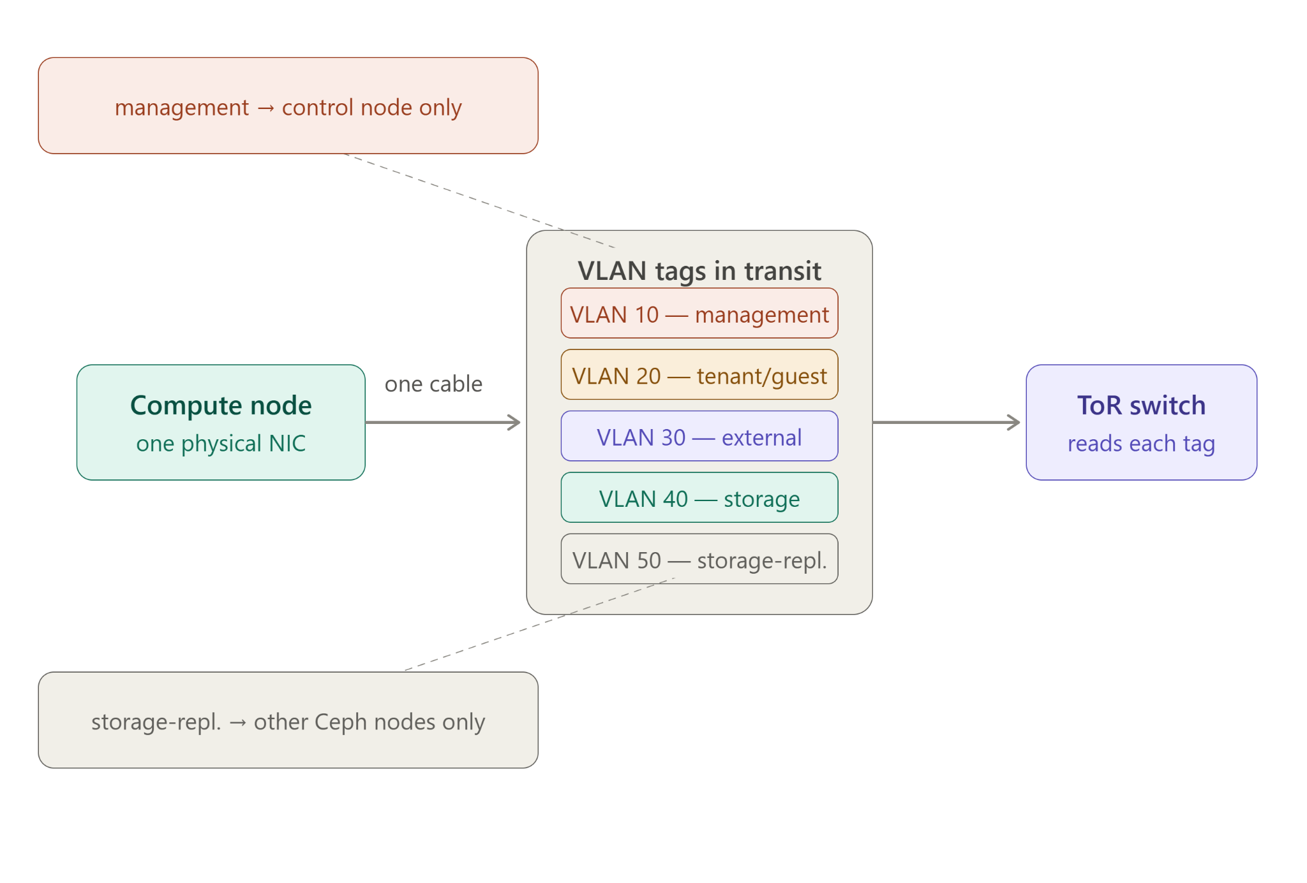
Every packet leaving a server gets a small tag stamped on it saying which network it belongs to, and the switch reads that tag to keep the conversations apart, even though they're travelling down the same wire.
The switch reads the tag on arrival and decides where that packet is allowed to go next
Technical Step 3 — Installing OpenStack itself: turning bare metal into a cloud.
The racked, cabled, and VLAN-segmented servers — but they're just plain Linux boxes. Installing openstack on each turned them into a cloud infrastructure using a deployment tool (Kolla-Ansible). SSH into every server and install the necessary containers, the Kolla Ansible packages the 4 compute nodes on each, as follows:
The order this actually happens in, first cloud only:
- Keystone first — the identity/authentication service. Nothing else can start without it, because every other OpenStack service has to prove who it is to Keystone before it's allowed to do anything.
- Glance — the image service, which stores the VM templates (an "Ubuntu 22.04" disk image, for instance) that Nova will later copy onto a compute node to create a VM.
- Neutron — the networking service, which gets configured with the actual VLAN ranges
- Nova — compute. Once identity, images, and networking exist, Nova can finally do its real job: take a request ("give me a VM"), pick a compute node, and boot it.
- Cinder — block storage, wired to talk to the Ceph nodes for persistent VM disks.
At this step, each servers now has a role of either a compute node, control node, storage node etc….
Technical Step 4 — First boot: standing up the actual cloud service, ready for customer zero.
After OpenStack is now running
- Define the tenant network — using Neutron, create the actual virtual network customer zero's VMs will sit on (their private IP range, their router out to the internet). This is where the VLAN plan from Step 2 becomes a concrete, usable network a customer can be assigned to.
- Upload a base image via Glance — e.g. an Ubuntu or Debian disk image. This is the "template" Nova will clone every time someone requests a new VM.
- Define flavors — Nova's term for VM sizes (e.g. "2 vCPU, 4GB RAM" vs "8 vCPU, 32GB RAM"). This is literally your product catalogue — the sizes customer zero (and later, other customers) can choose from.
- Create the Cinder volume types — mapping to the Ceph pools we built, so a customer's VM can request persistent block storage.
- Boot the first test VM — the actual "does this work" moment: request a VM, watch Nova pick a compute node, watch Glance hand over the image, watch Cinder attach a disk, watch Neutron assign it a network address. If that VM boots and answers a ping, the cloud is technically alive.
- Onboard customer zero — migrate or deploy their actual workload (from your infrastructure map — e.g. Odin's compute/storage/networking needs) onto this now-working cloud.
… and like AWS, operate as an “Illusion of infinite capacity”, ensuring the mandate to “never say no when a customer asks for a machine”

